Manage your anger before it manages you!

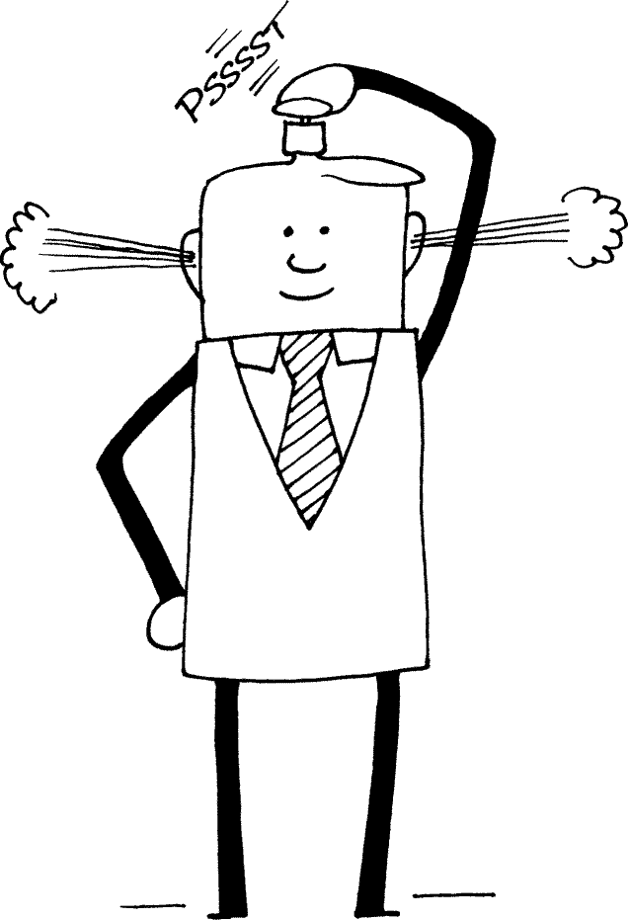

Anger management does not mean never getting angry, internalizing, or suppressing your anger but rather learning better ways to handle problems and frustrations that lead to anger, as well as learning to work through and channel that negative energy into something positive and life-bringing.

Here are a few anger management tips, to make sure you always keep a cool head.

- Compromise. Ah, that age-old word. Easy to say, harder to apply. But like willpower and patience, the ability to find solutions that benefit both parties will carry you further in your career than your degree. Apply problem-solving tools to replace worry; suggest an alternative solution.

- Withdraw. Step back and leave situations that make you angry. Try imagining you’re looking at the tense situation like it’s a movie. You’ll be surprised at the insights you can gather! It’s better than letting it get worse. Rather leave the confrontation, cool off, and revisit the matter from a calmer and more reflective perspective.

- Let it go. Just because something’s making you angry BECAUSE you’re right doesn’t mean it’s the end of the world. And it doesn’t mean you have to confront it. The only crusade you should be on is yours. Learn to let the little things go. Remember, you can’t control everything.

- Deep breathing. The best way to take your attention off the dark mental carousel your ego is on is to breathe deeply and slowly with full attention on your breath. Not only will this oxygenate your brain and body, but it will bring your mind to where it really matters – here and now.

- Laughter is the best medicine - use humour and laugh! The best stories of your life will usually come out of the craziest situations. Life is a grand comedy, and you’ll be much happier living that way.

- Exercise to release those endorphins (feel-good hormones). You’re much less likely to get worked up or feel stressed if your brain is chock full of endorphins. Most of the time we let situations get worse by letting them get to us. But as you work out, you release not just the sweat but all the negative energy and anger, leaving you feeling lighter, happier, and with a toned body to show off!

